Rest POC

This document describes about the functionalities available in the REST Consumer UI developed using JQuery.

UI client consumes the REST services and display the JSON data received from the service in the UI.

The functionalities available in the UI client are explained below.

1. Get all Users.

When the page loads, the client makes a GET request to fetch all the users information stored in the database. The service returns the list of user data in JSON format, which is displayed in the table shown below.

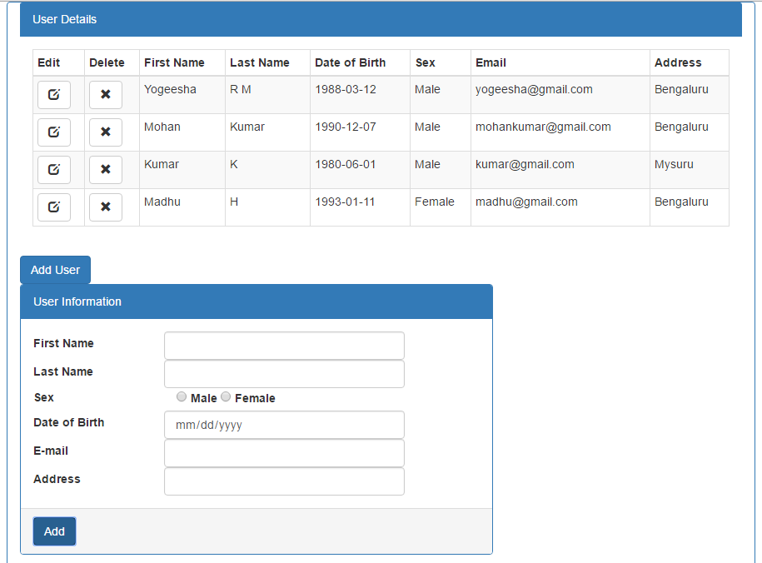

1. Add a new User

There is a user form to enter the details of the new user to add into the system.

There is also a button provided to add the new user.

* Click on Add User button to add a new user into the system.
* Enter all the details in the form and click on add button provided in the footer of the create form.
* Client makes a POST request to the service by passing the user information in the request body as a JSON.
* Upon receiving the success response from the server, new row will be added in the table with the new details.
* The create form will be cleared.

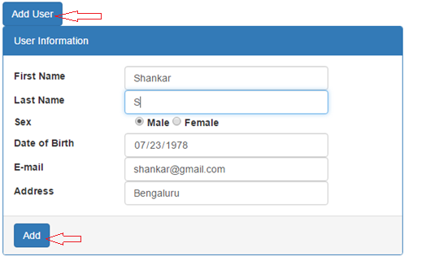

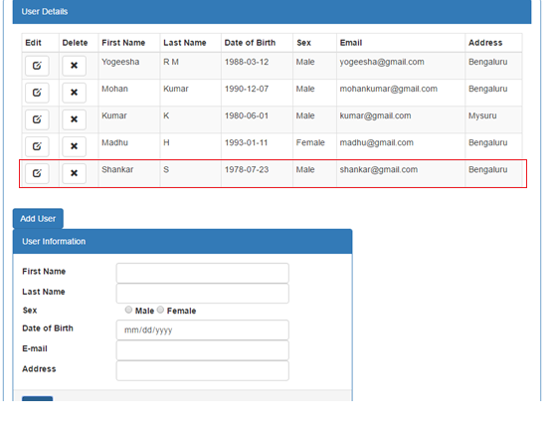

1. Update user details.

The user details can be updated in the system.

* Click on the edit icon provided in the first column of the table in the specific row for which the data needs to be updated.
* Client makes a GET request to the service by passing the userId as a parameter and gets the selected user information in the response in JSON which will be populated in the user form provided below for the update.
* After modifying the information, click on the Update button provided in the footer of the update form.
* Client makes a PUT request to the service by passing the modified information in the request body in JSON.
* Upon receiving the success response from the server, selected user row will be updated in the table with the modified details.
* The edit form will be cleared.

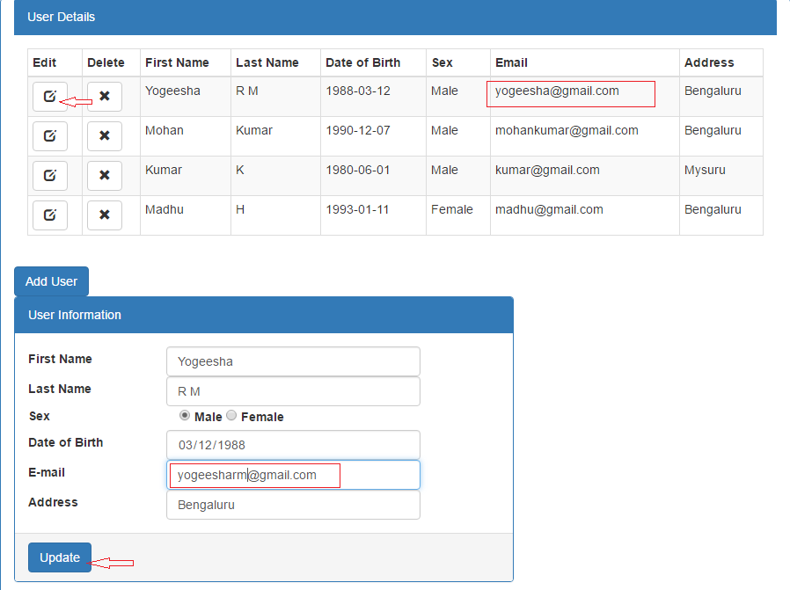

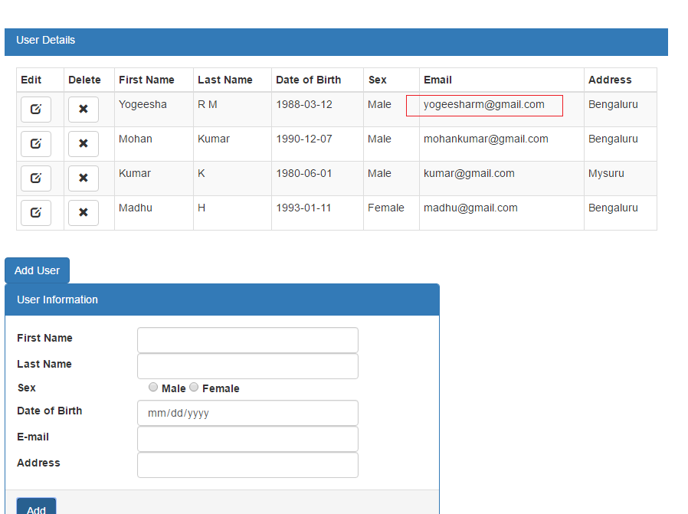

1. Delete User details

The user details can be deleted from the system.

* Click on the delete icon provided in the second column of the table in the specific row for which the data needs to be deleted.
* An alert for delete confirmation pops up.
* On confirmation, Client makes a DELETE request to the service by passing the userId as a parameter.
* After receiving the response, success message will be displayed.
* The deleted user information will be deleted from the table.

